**Data Manipulation in Pandas :**

**(1) Deleting Columns :**

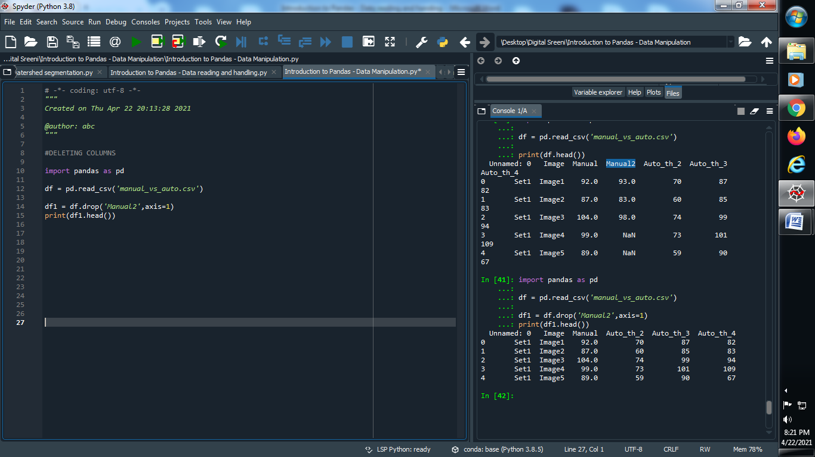

**Output :**



**(2) Delete Multiple Columns :**

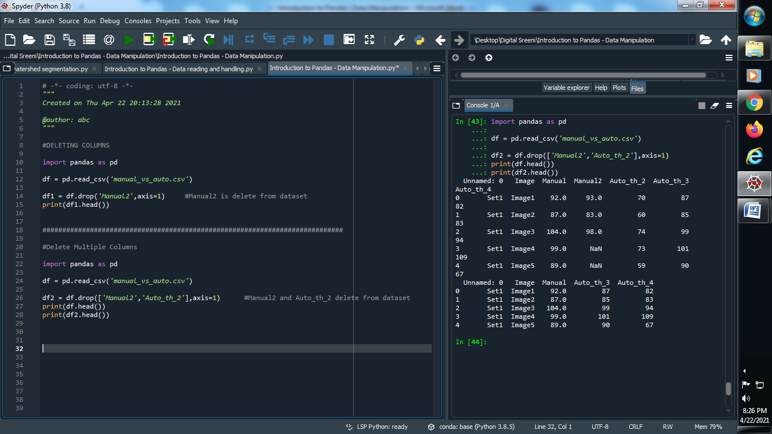

**Output :**



**(3) Insert New Columns :**

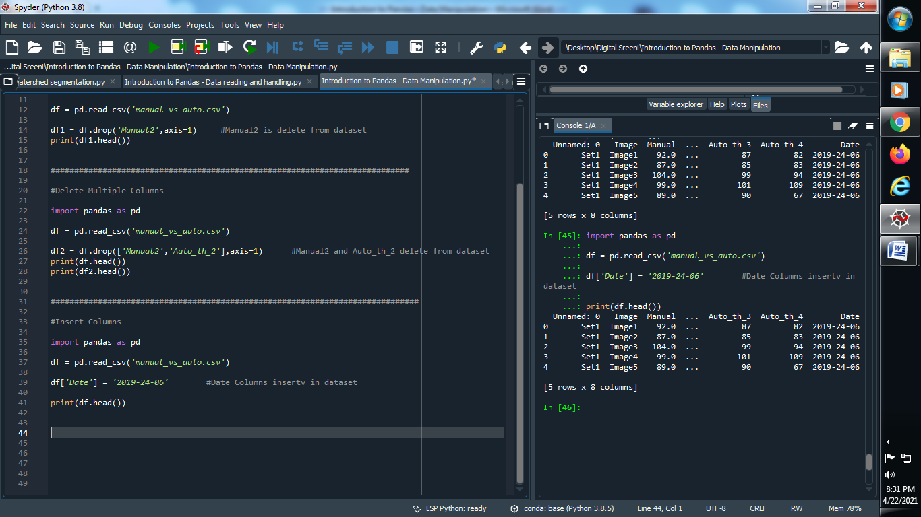

**Output :**



**(4) Change datatypes :**

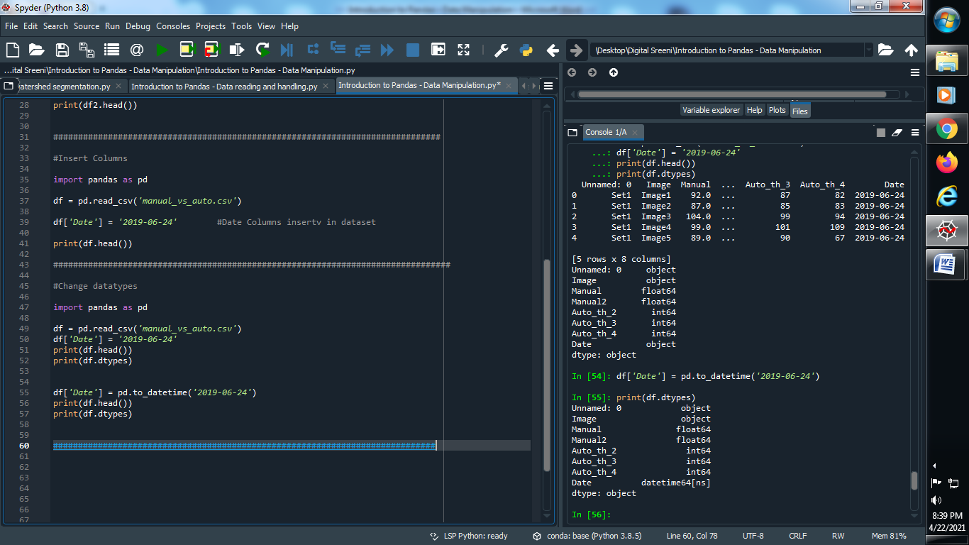

**Output :**



**(5) Create a new csv file or rename and update exist csv file**

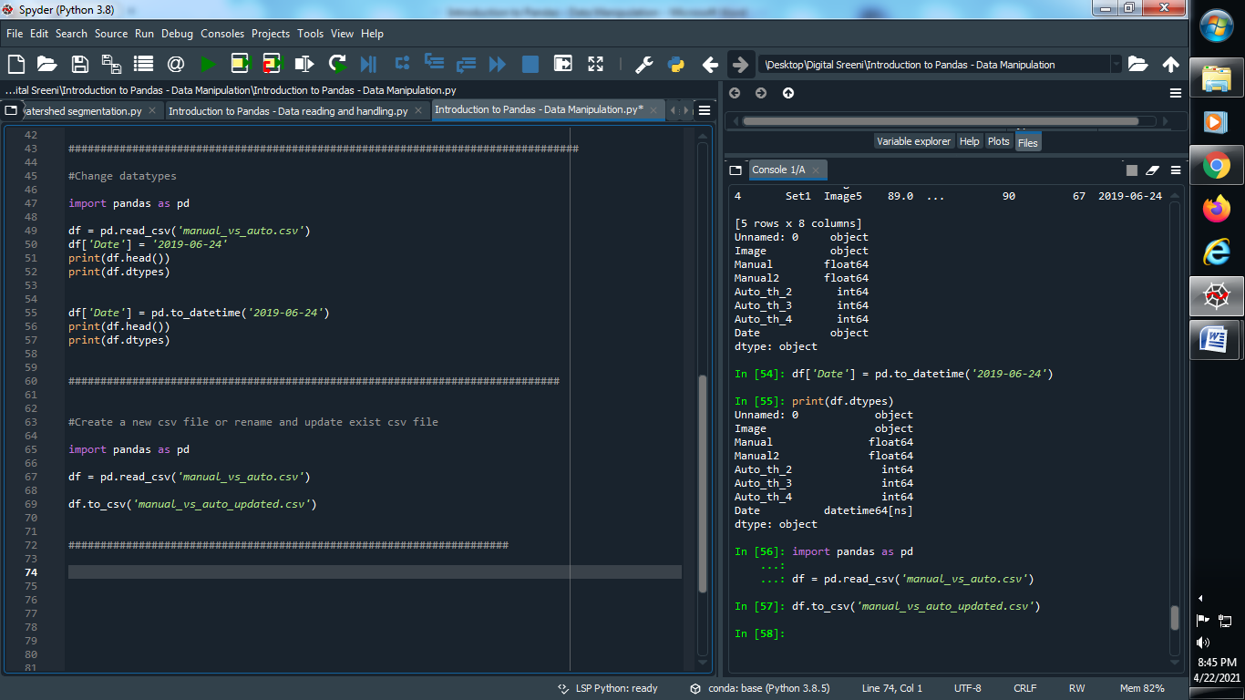

**Output :**

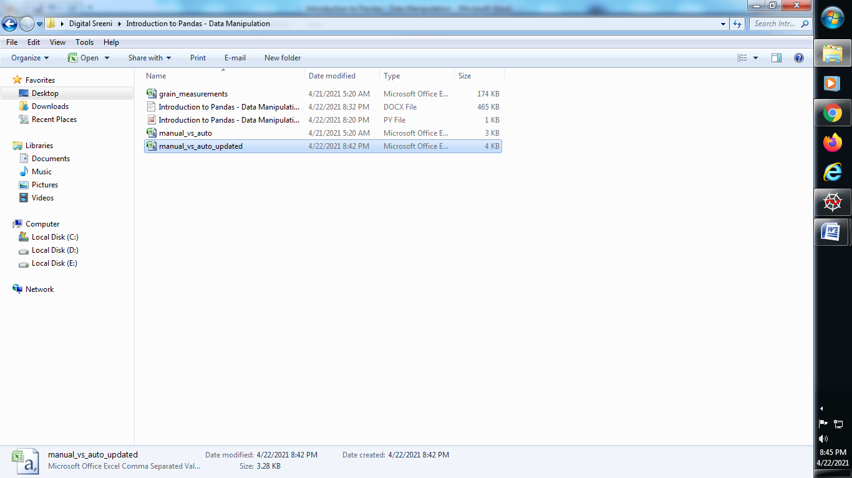

**(6) Delete Rows :**

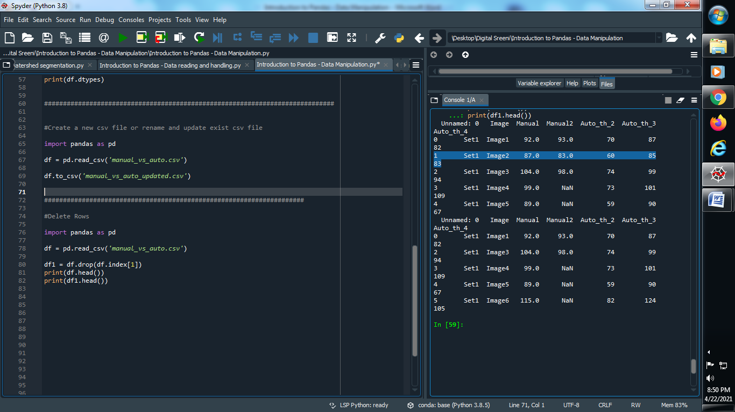

**Output :**



**(7) Delete Multiple rows :**

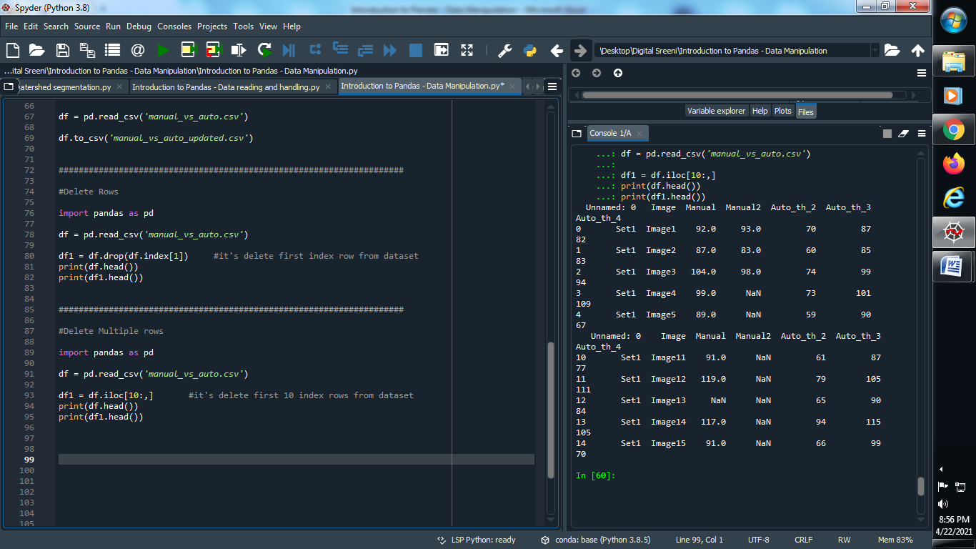

**Output :**



**(8) Delete particular one set from dataset :**

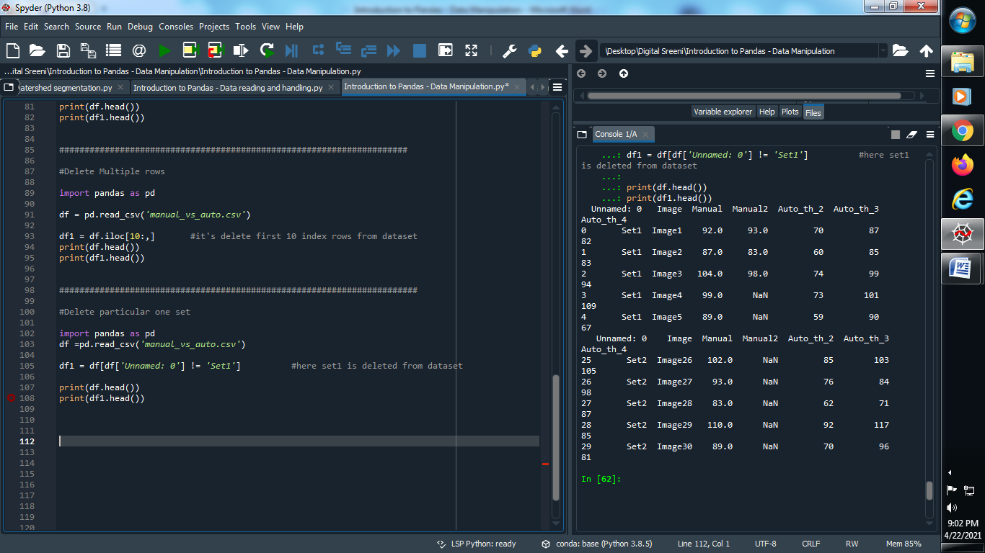

**Output :**

